Linux Command and Usage
1 Ls – List all the content of file
Usage - Ls
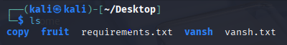

2 Mkdir - Make a new directory
Usage – mkdir
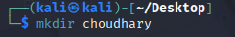
3 rmdir – Remove an empty directory
Usage – rmdir
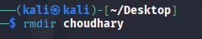
4 pwd – Show the present working directory
Usage – pwd
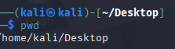
5 cd – change the working directory
Usage – cd
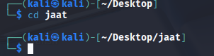

6 rm – r – remove a directory with some content
Usage – rm-r
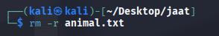
7 cd .. - going to the previous folder
Usage – cd ..
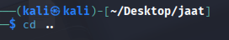
8 ls –a – List all the hidden files of the system
Usage – ls –a
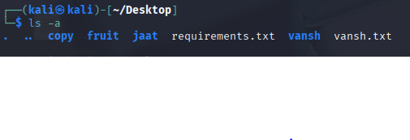
9 sudo apt install – To install anything with admister power
Usage – sudo apt install
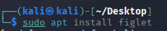
10 Clear – clear the terminal screen
Usage – Clear
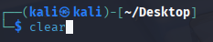
11 Exit – exit the terminal
Usage – exit
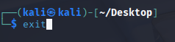

12 Mousepad - create a file
Usage – Mousepad

13 History – give the list of all the command that we have ran in the terminal
Usage – History
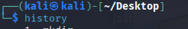
14 Cat – Tell the file type
Usage – Cat
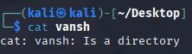
15 Figlet “ text “ – change the text into figlet font
Usage – Figlet “ Vansh “
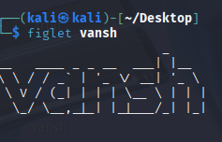
16 Ping google.com – tells the current speed of the internet
Usage – Ping google.com
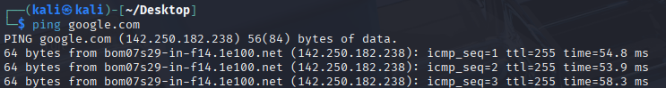
17 Cowsay “ text” – make the text said by cow
Usage – Cowsay
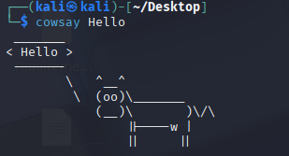
18 Top - monitor system in real time at linux
Usage – Top
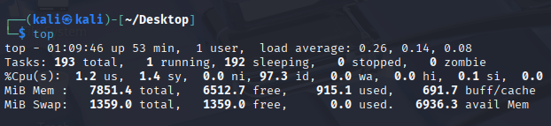
19 toilet “ text “ – Print the large ASCII text banner
Usage – Toilet “ Vansh “
